Lab: 2D-str. predictions and membrane predictions
1. What are the differences between secondary and tertiary structure?

A structure, which is observed to be secondary, has distinct structural characteristics. It is stabilized by intramolecular hydrogen bonds. Examples are alpha-helix or beta-sheets.
The next hierarchical step is the tertiary structure, in which secondary structure components inside a protein build a 3-dimensional structure by using for example covalent bonding (disulfide bridges between two cysteine residues) or Van-der-Waals Bonds.

2. Why do researchers want to predict protein secondary structures from sequences?

The knowledge of secondary structure can help to form a multiple sequence alignment, because it gives more information about the protein. Additionally, classification of structural motifs and protein domains, fold recognition and ab initio protein prediction can be improved.
The main reason is, that one can use the already existing sequences from several databases, such as Uniprot, to predict the secondary structure, which is much easier and much cheaper than performing a real structure analysis (ab initio). Another reason is, that the databases of sequences is still growing. Having the structure is very important to access the function of the protein. Specifically secondary structure prediction is important for predicting 3D-structure later.

3. What is the Swissprot accession number of the sequence?

P02144

4. How many helices longer than five residues are predicted by the method?

7

5. Find the myoglobin (human) protein structure in pdb. How many alpha helices does it have? (Hint: look for the word HELIX in the .pdb file)

8

6. Submit the sequence of chicken c-fos to MARCOIL and COILS. Compare the predictions and describe the results you get?

There is a prediction for coiled structure by both the algorithms between amino acid position 150-200. The COIL algorithm for a window of 28 residues matches best to the MARCOIL algorithm. The other windows (14, 21 residues) were different. Window 14 shows a breakage of coil at approximately position 155.

1. Pick your favorite transmembrane helical protein and describe based on it the typical features of transmembrane helices.#

The EGF-receptor (epidermal growth factor) is a helical transmembrane protein. As being a single pass protein, its 23aa helix passes the membrane only once. Since it is non-polar inside the membrane, transmembrane proteins have to have non-polar sidechains as well to remain inside the membrane. The ends of the helices, which point to the transition region (inner/outer membrane transition), usually contain a significant amount of Trp and Tyr. These amino acids are non-polar, nevertheless they have some part of polarity, which allows them to fit perfectly into the transition region.

2. What does membrane protein topology mean?

Membrane protein topology describes the number and the location of the different domains/subparts from a single membrane protein, which can be inside the membrane, outside or within the membrane. Furthermore, it describes the orientation of the membrane segments.

3. How many transmembrane helices were predicted by the two methods for 1j4n.fa? Include screenshots of the predictions.

6 transmembrane helices
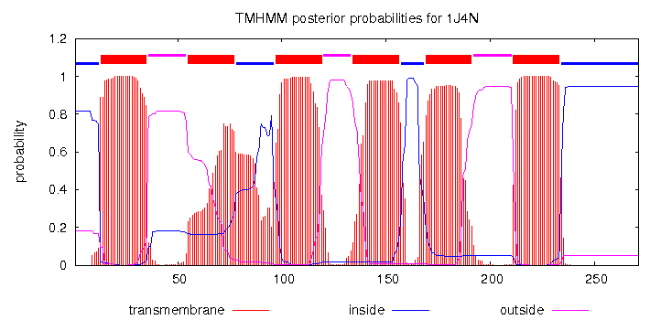

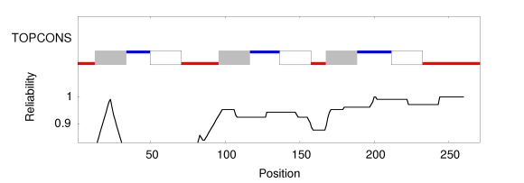

4. Are the N- and C-termini of the sequence predicted to be inside or outside of the cell membrane?

The N- and C- termini are predicted to be inside of the cell membrane.

5. How many helices with at least 5 residues were predicted using the method?

8

6. Explain the difference between predicting secondary structure and predicting the membrane protein topology.

In order to predict the membrane protein topology one has to take into account the positive inside rule and the specifications concerning the transition regions between the inner part and the outer part of the membrane. General prediction for secondary structure does not take these into account

7. Go to pdb and find the experimentally determined structure of the protein. What is the name of the protein?

AQP1 water channel, membrane protein, Bos taurus

8. How many helices do you think the protein has? Include a screenshot of the image.

9
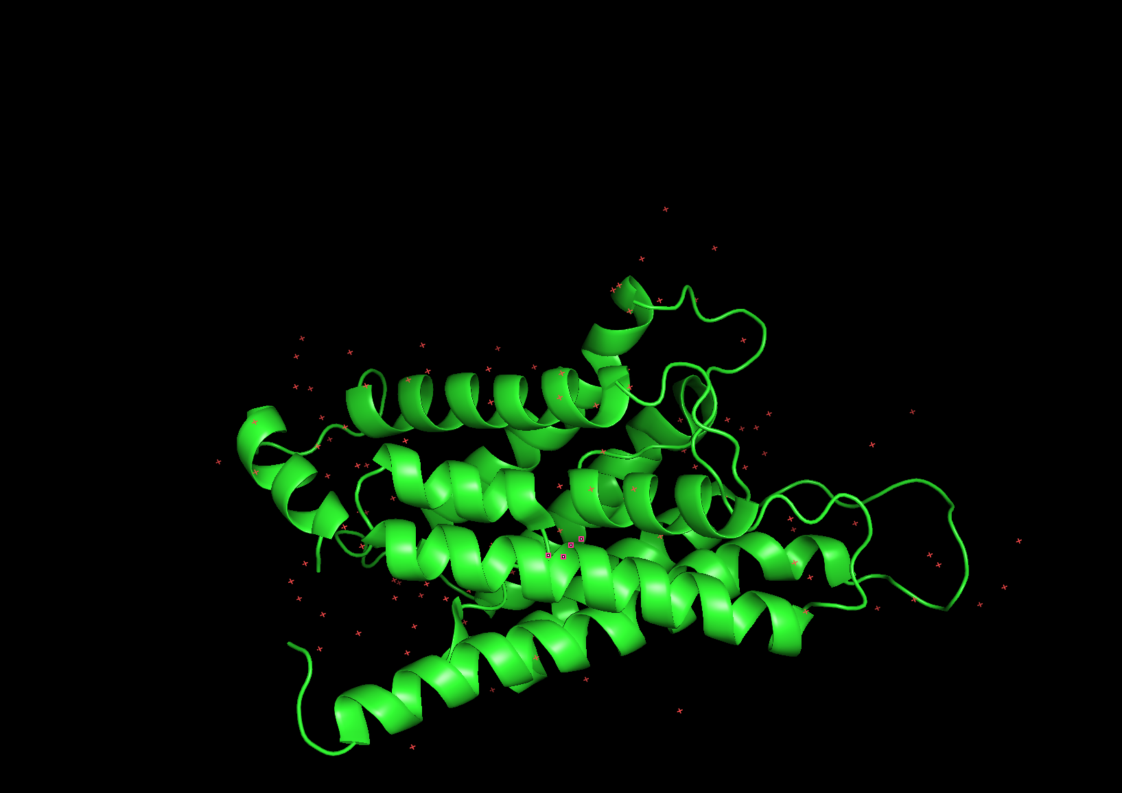
9. How many transmembrane helices do you think the protein has? Motivate your answer.

A transmembrane helix has an average length of approx. 18 residues, so when comparing with the pdb file, there are 6 helices with more than 18 residues. https://www.sciencedirect.com/science/article/pii/S0014579304000614

10. How many helices do the determined structure contain according to DSSP and STRIDE? Does this result agree with your predictions and your visual inspection? Why / Why not?

STRIDE: 11 helices
DSSP: 12 helices
Stride predicts 11 helices, because STRIDE includes 3/10-helices (2 predicted by STRIDE). DSSP predicts one 3/10-helix more than STRIDE (at position 140), this could be caused by the different parameters used by DSSP and STRIDE. In the end, both algorithms predict the same amount of alpha helices (9), which is the same amount as my prediction.

